**NABU Computer Diagnostics **

**Version 1.7.5 Created in March 2023**

*Created by Rudy’s Retro Intel* <https://www.youtube.com/@RudysRetroIntel>

Please email me ([retrointeldiy@gmail.com](mailto:retrointeldiy@gmail.com)) if you would like to add to this document. Future versions will be available as more information is collected, tested and verified.

*Additional support provided by*:

* Geek With Social Skills (<https://www.youtube.com/@geekwithsocialskills>)
* The technical manual and schematics for the NABU PC were done by MJP while reverse engineering the NABU PC. MJP are his initials and on the original PDF (NABU_Computer_Technical_Manual_by_MJP.pdf)
* NABU Personal Computer User’s Manual
* Data sheets found at <https://www.datasheets.com> , <https://datasheetspdf.com/> and <https://archive.org/details/ic_datasheets?and%5B%5D=subject%3A%22office+box%22&sort=-date>
* IC pinouts, visit <https://www.futurlec.com/IntegratedCircuits.shtml>
* Joe’s Computer Museum (<https://www.youtube.com/@JoesComputerMuseum>)

For the latest version of this document and other NABU related information, use the links below.

<https://www.nabunetwork.com>

<https://github.com/RudyRetroIntel/Vintage-Computer-Diagnostics>

*“Thank you to everyone who helped with this documentation. With this knowledge we can ensure that the NABU computer can be repaired and enjoyed now and into the future.*

*Rudy’s Retro Intel”*

***\*\* This document is based on the work I have performed on my NABU computer and is provided “as is”. I\we do not take any responsibility for errors and\or damages that may occur when repairing your NABU computer. This is information is provided freely to all NABU computer owners. Please ensure you know how to perform electronics\electrical work. If not, please contact someone who has these skills before starting. \*\****

This NABU computer diagnostics document was created to help diagnose issues with a NABU computer. My diagnostics and recommendations are based on the motherboard revision 01. Image below.

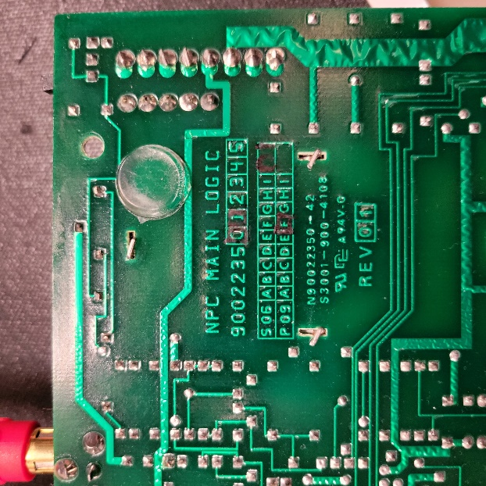

*\*Check your board revision as these diagnostics may differ.*

**Index**

*The NABU Computer Configuration - Page 4*

*Location of ICs - Page 5*

*Pictorial Diagnostics - Page 6*

*Complete System Failure - Page 7*

*Network Adapter Failures - Page 8*

*Keyboard Failures - Page 9*

*Sound Failure - Page 11*

*Serial Failure - Page 11*

*LED Display Failures - Page 12*

*System RAM Failures - Page 13*

*Video RAM Failures - Page 15*

*Card Slot Failure - Page 19*

*Parallel Port Failure - Page 20*

*NABU Computer Schematics - Page 21*

*IC location and Part Numbers - Page 27*

*NABU Connector Pinouts - Page 28*

*Keyboard Encoding Chart - Page 29*

*NABU Memory Map - Page 30*

*Bodge Wires Connection - Page 31*

*IC Pinouts - Page 44*

*NABU Adapter Cable Connection - Page 51*

**The NABU Computer Configuration**

* Processor (CPU) is a Zilog Z80A microprocessor running at 3.58Mhz
* Total of 80K of memory and is configured to use 64K for the Z80A processor and dedicated 16K for video memory
* Frequency comes from a 10.735635Mhz crystal which is divided down to 3.579545 (3.58) Mhz
* Four slots are available to add additional cards
* ROM is a 4K byte which contains the bootstrap software. Other boards have an 8K ROM
* Outputs to composite or a NTSC frequency via the RF modulator. Text mode = 24, 40-character rows in 2 colors. Graphic mode = 32 x 24. Total screen resolution is 256 x 192 pixels, 15 colors plus transparent capabilities, sprite-oriented, hardware-supported animation
* Keyboard uses an unregulated +10VDC to power the unit and receives\sends via an EIA RS422 over twisted pair cable with shield at 6992 BAUD rate
* Printer port uses a DB-15 (female D-Type) Centronics parallel printer standard connection with handshake
* Audio output is 10K ohm output impedance, 1.5V p-p signal for driving separate audio amplifier or input to a monitor
* Adapter port provides a full duplex, 111 Kbit per second serial interface

***\* Any software troubleshooting is beyond the scope of this document. Here we will only cover hardware related issues****. \**

**Location of ICs**

The image below shows the location of all major ICs. Use this as a reference.

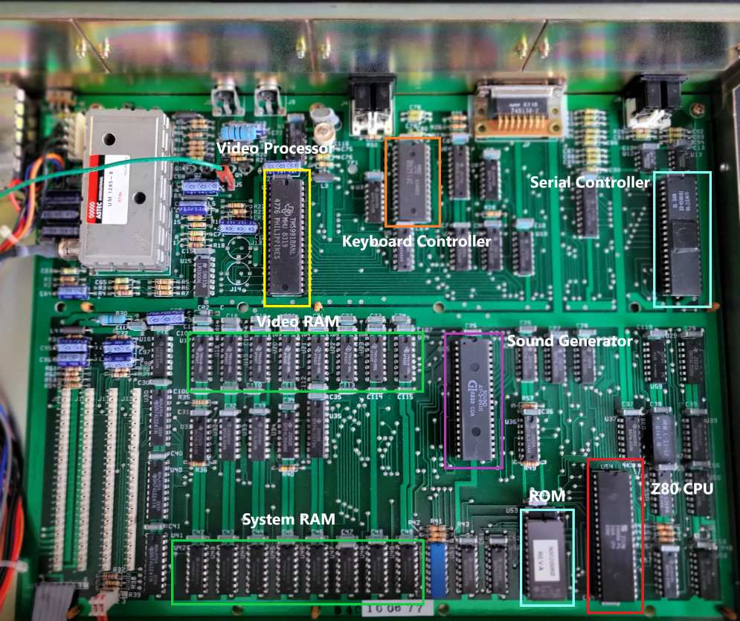

Video IC: TMS9918ANL – Video Display Controller by Texas Instruments

Keyboard IC: D8251AC – Programable Communication Interface by Rochester

Serial\Network IC: TR1863-B-02 – Universal Asynchronous Receiver/Transmitter by Western Digital

CPU IC: Z80A – Microprocessor by Zilog

Sound IC: AY-3-8910 – Programmer Sound Generator by ETC

ROM: 2732G EPROM

Video Memory ICs: TMS 4116-15NL by Texas Instruments

System Memory IC: HM4864P-2- 65536 x 1 Bit DRAM by Hitachi

**\* When placing the lid on the NABU computer, ensure that the side with the holes is on the side closest to the motherboard. If you place the lid on the opposite way, the system can\will over heat. These holes allow for cooler air to pass over the motherboard and into the power supply. From there, the hot air is expelled out the back of the power supply via the built in fan \***

**Pictorial Diagnostics**

With your NABU computer turned on, view the following images and find the one that closely matches what you are viewing on your screen. Next look at the corresponding diagnostic information.

* Where possible, links to vendors where parts can be purchased will be show. No affiliation with any vendors. Check your favorite vendor for replacement parts
* IC pinouts outs are included where available. See “*IC Pinouts”* in the index
* **NOTE: Your *background color may be different. My background is blue however the video capture device changed it. This doesn’t matter as the images will be the same.***

**Complete System Failure**



*Symptom*: Black screen, no sound. The Alert LED located on the front panel may be ON.

*Diagnose*s: This is a major fault and the following needs to be tested\replaced.

Test\Replace Power supply

* + Check power plug is connected and power is available from wall socket
  + Check fuse located inside power supply. See image below
  + Ensure motherboard connection to the power supply is connected and secure. See image below
  + Press down all ICs in sockets, as they can have poor contact(s) due to heat
  + Ensure that the lid side with the holes is on the side closest to the motherboard
  + Other possible issues could be related the power supply electronics. Future versions of this documentation may cover power supply repairs
  + Inside power supply. Note the motherboard connector and fuse locations.

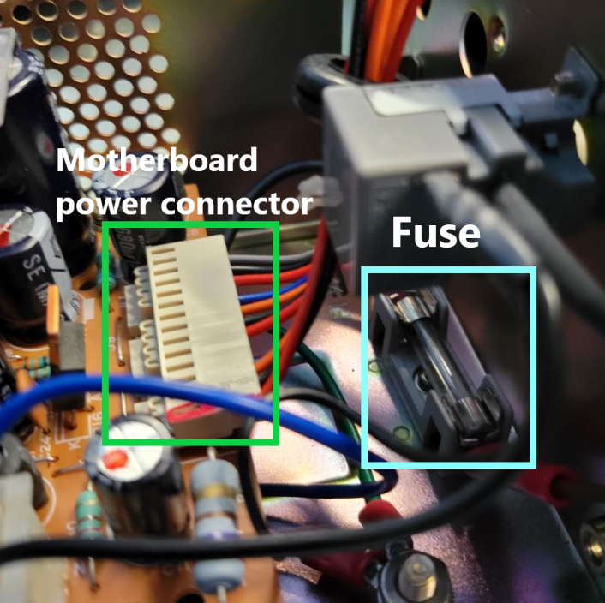

Test\Replace video cables and\or monitor\TV used.

Test\Replace ROM – **U53** - 2732G EPROM: Burn new EPROM and replace

Test\Replace Video processor – **U2** - TMS9919ANL**.** See pinout diagram on next page

Test\Replace CPU – **U54** - Zilog Z80 processor.See pinout diagram on next page

Test\Replace Transistors 2N3904

**Network Adapter Failures**

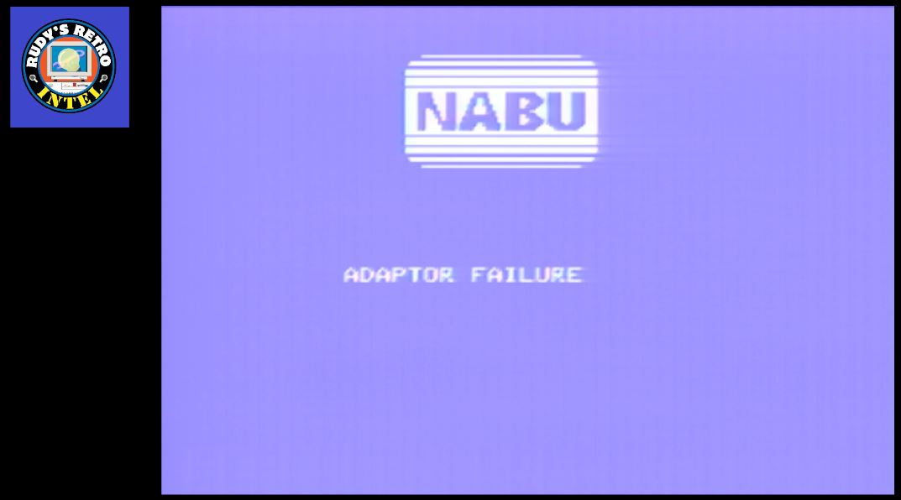

*Symptom*: Failure to connect to the NABU network.

*Diagnoses*: This is normal if you do not have a connection to the NABU server\network. If connecting to the network and are getting this error, check connections and network status.

If errors are still present test\replace **U14** - TR1863P-02, **U29** - 74LS32, **U12** UA9637ACP and\or **U13** - UA9638ACP, **U32** - 74LS00

**Keyboard Failures**

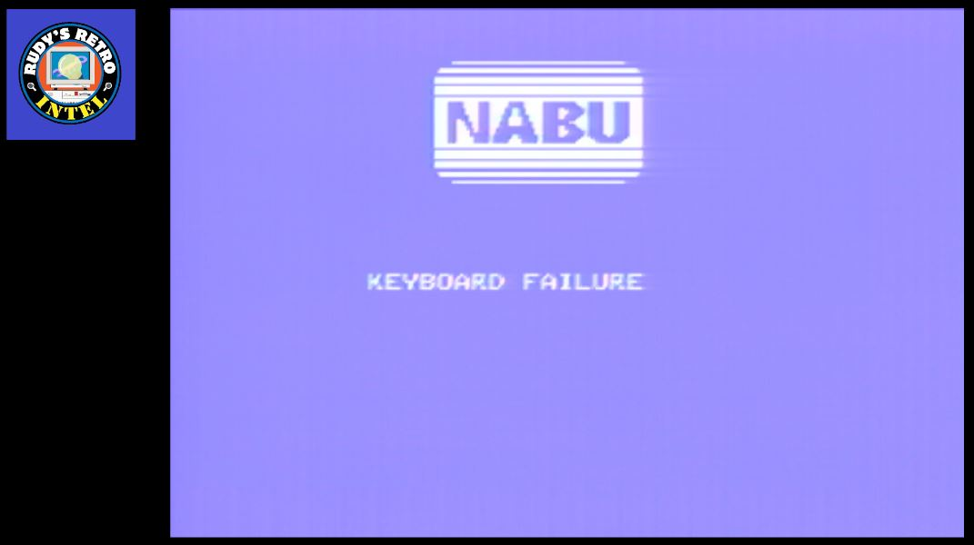

*Symptom*: Keyboard not working.

*Diagnoses*: Check that the keyboard is connected to the NABU computer.

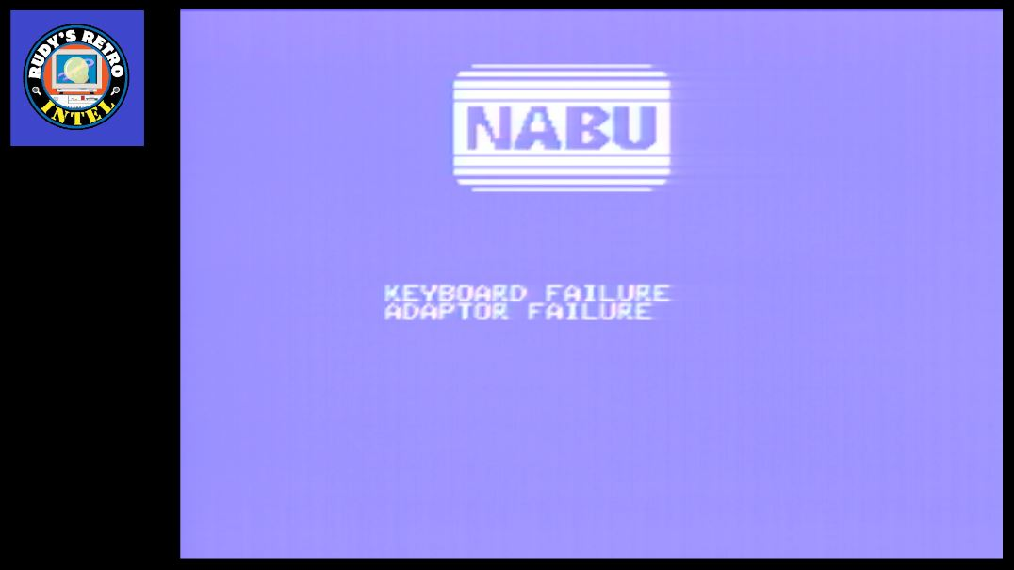

*Symptom*: Keyboard connected properly however; Alert LED is ON.

*Diagnoses*: Replace **U4** - D8251AC, **U8** - 74LS32 *within the NABU PC.*

**Keyboard Internals**

Logic board inside the keyboard itself.

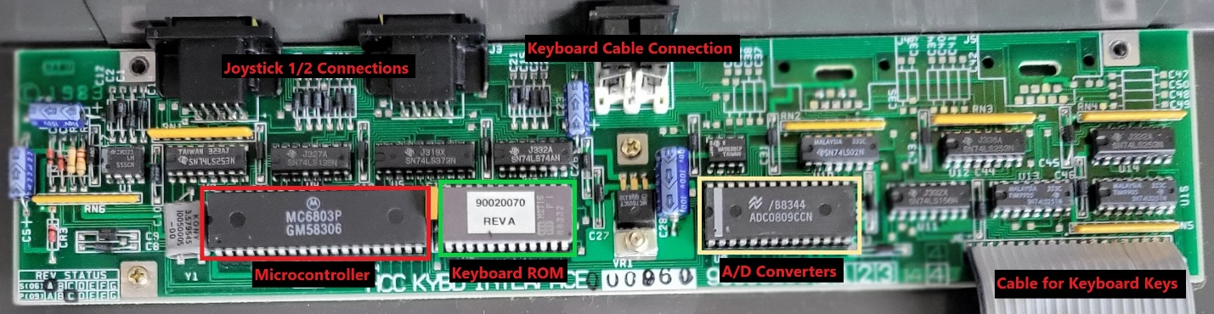

With continued keyboard issues, the following should be tested\replace as needed.

*Diagnoses*:

**MC7805T** - 7805 5V 1A Positive Regulator – Ensure proper voltage is present

**Ribbon Cable** – Cable to connect logic board to physical keys – Check for damage and verify continuity

**MC6803P** - 8-Bit A/D Converter with 8-Channel Multiplexer – Use datasheet and oscilloscope

**ADC0809CCN** - Converters with 8-ChannelMultiplexer – Use datasheet and oscilloscope

**ROM** – Custom NABU PC keyboard ROM – Use datasheet and oscilloscope

**555** – Timer IC – Use datasheet and oscilloscope

All support ICs – Review each IC’s logic with datasheet and oscilloscope

**Sound Failure**

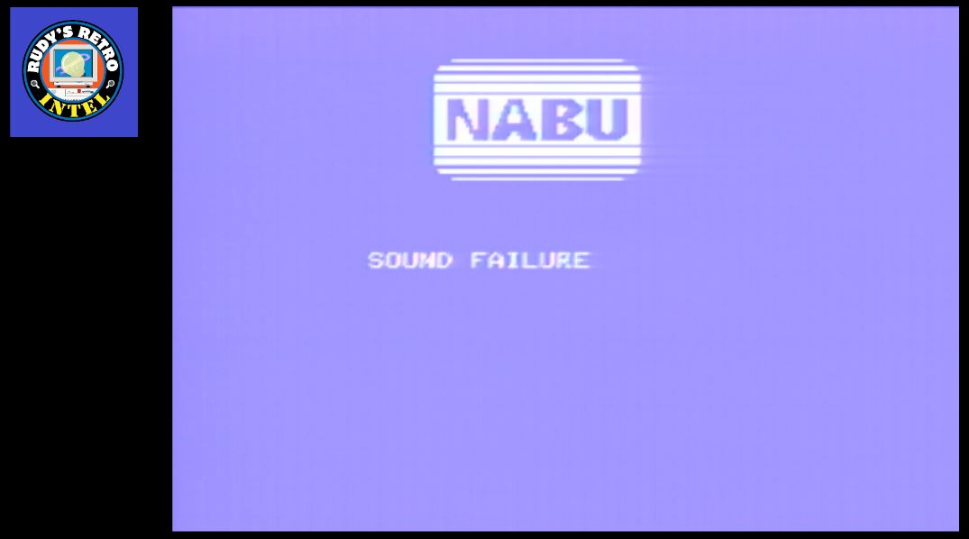

*Symptom*: Sound Failure message, no sound heard, Alert LED on.

*Diagnoses*: Replace **U25** - AY-3-8910 sound generation IC. **U15** - LM3900, **U35** - 74LS373,

**U54** - Z80 processor, **U26** -74LS153, **U27** – 74LS32, **U39** – 74LS00, **U36** - 74LS74, **U28** - 74LS38,

**U34** - 74LS348, **U32** and **U33** - 74LS00, **U1** - 74LS14

**Serial Failure**

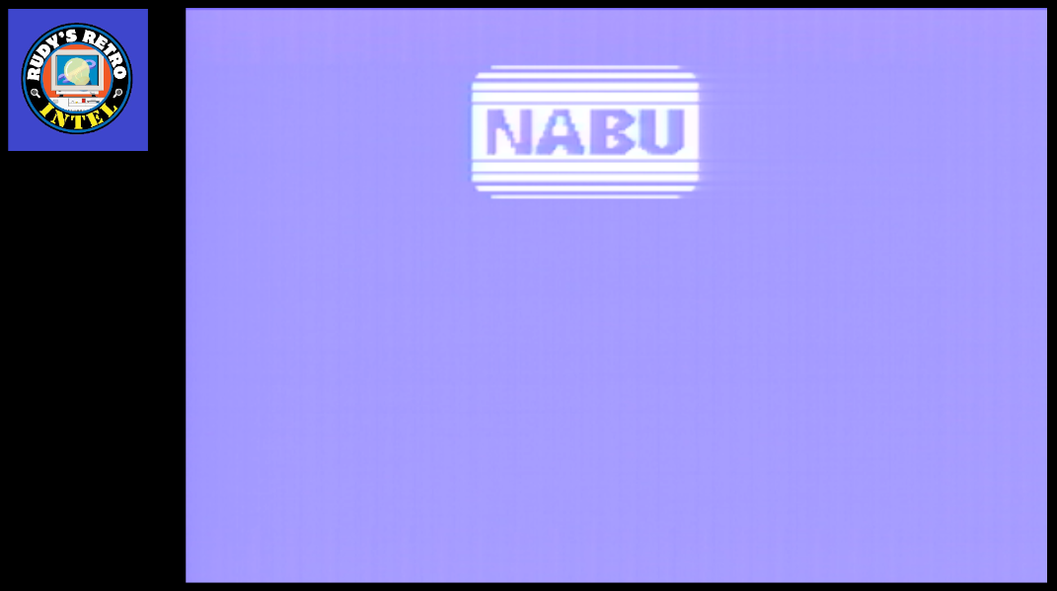

*Symptom*: NABU logo and no other characters.

*Diagnoses*: Replace **U14** - TR1863-B-02 – Universal Asynchronous Receiver/Transmitter

**LED Display Failures**

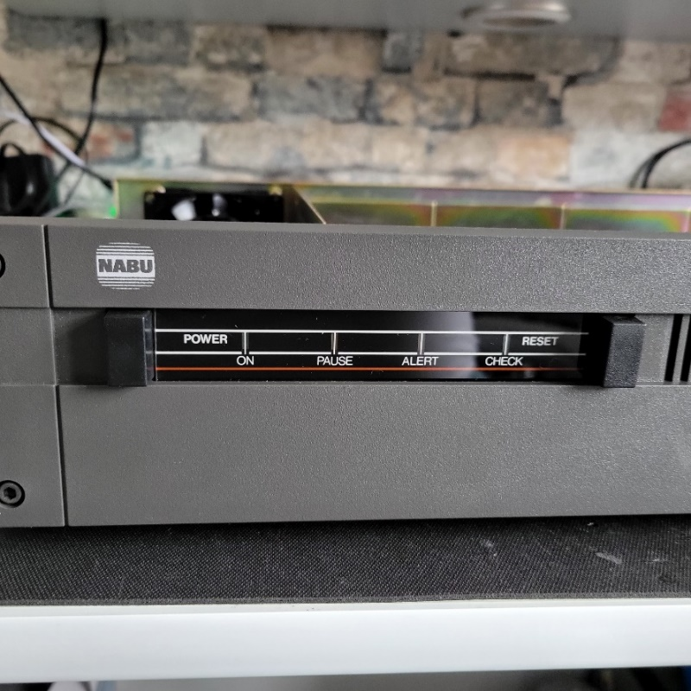

*Symptom*: NABU computer LEDs not displaying or have some not working

*Diagnoses*: Replace **U5** - SN7406, **U6** - 74LS273, replace LED(s), Check +5VDC, **U8** and **U27**– 74LS32

**System RAM Failures**

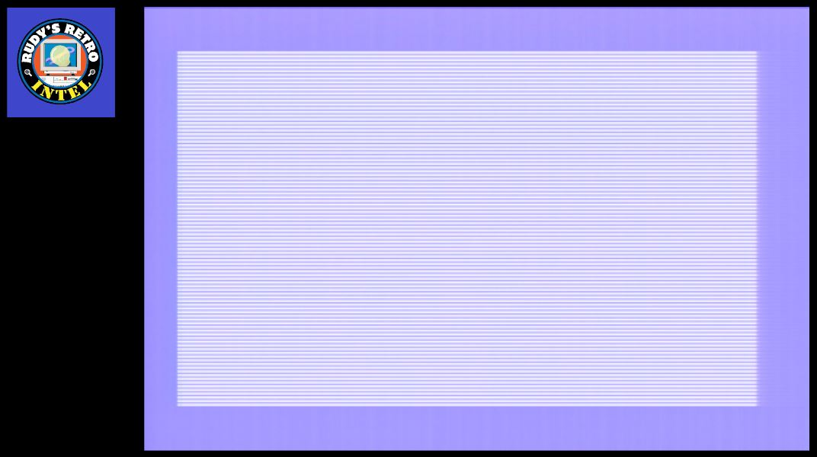

*Symptom*: No text, small\fine vertical bars.

*Diagnoses*: Replace **U42, U43, U45**, and\or **U49** - HM4864P DRAM, **U51** and **U52** – 74LS157, **U54** -Z80 CPU, **U37, U9, U57** – 74LS32, **U39** – 74LS00, **U56** – 74LS04, **U36** – LP76-57, **U55** – 74LS260, **U28** – 74LS38

 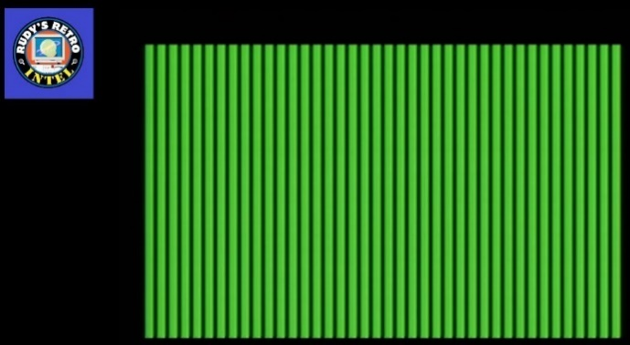

 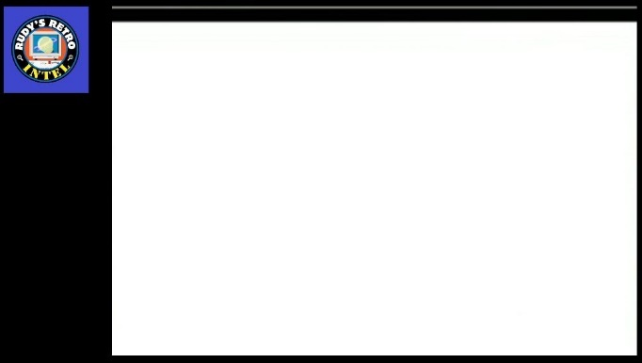

*Symptom*: Solid color, vertical green bars, scrambled colors and\or white screen.

*Diagnoses*: Replace **U44** with HM4864P – DRAM Chip DRAM 64Kbit 64Kx1 5V.

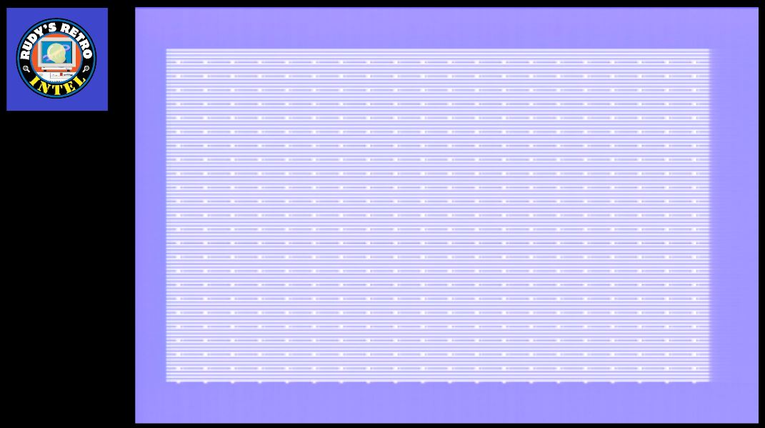

*Symptom*: Fine stripes with dots aligned vertically and horizontally.

*Diagnoses*: Replace **U46** - HM4864P – DRAM Chip DRAM 64Kbit 64Kx1 5V.

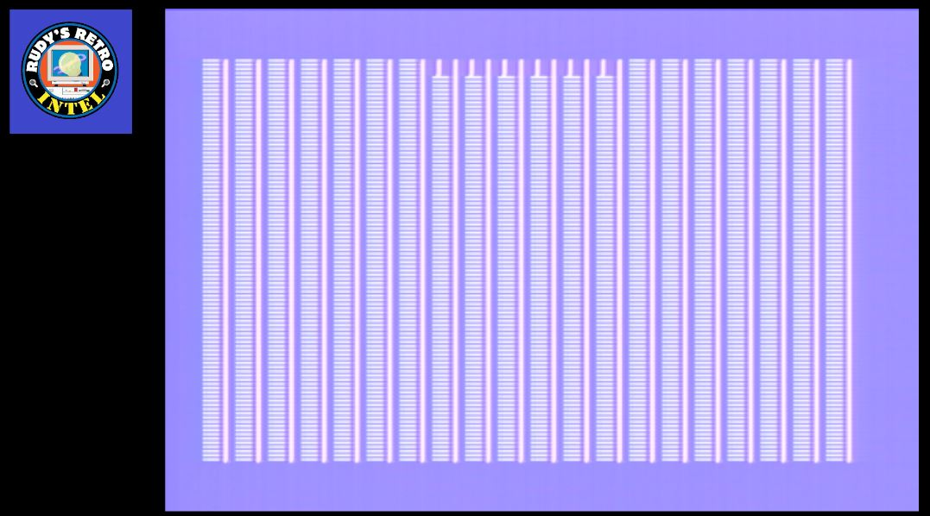

*Symptom*: Vertical bars (solid and non-solid bars), NABU logo tries to display.

*Diagnoses*: Replace **U47** - HM4864P – DRAM Chip DRAM 64Kbit 64Kx1 5V.

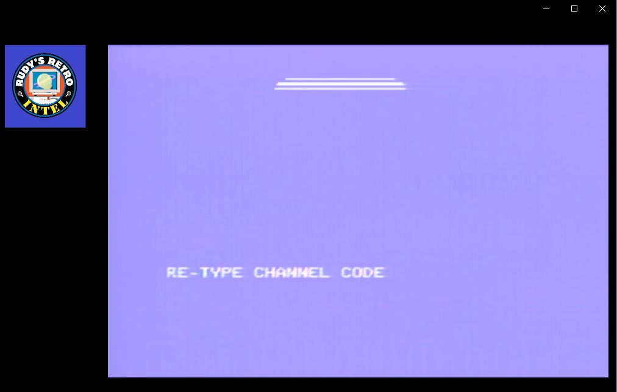

*Symptom*: NABU logo tries to display, Error: “RE-TYPE CHANNEL CODE” appears. This screen may disappear and reappear, flashing message.

*Diagnoses*: Replace **U48** - HM4864P – DRAM Chip DRAM 64Kbit 64Kx1 5V.

**Video RAM Failures**

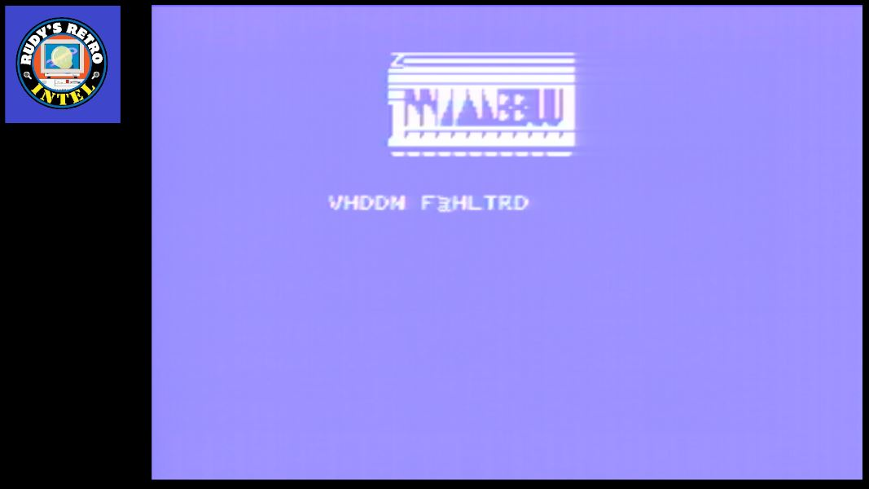

*Symptom*: NABU logo and text characters not shown correctly.

*Diagnoses*: Replace **U17** - TMS4116-15NL – DRAM, **U3** – 74LS32, **U1** – 74LS74, **U59** – 74F04, **U56** – 74LS04, **U7** – 74LS74, **U31** – 74LS14

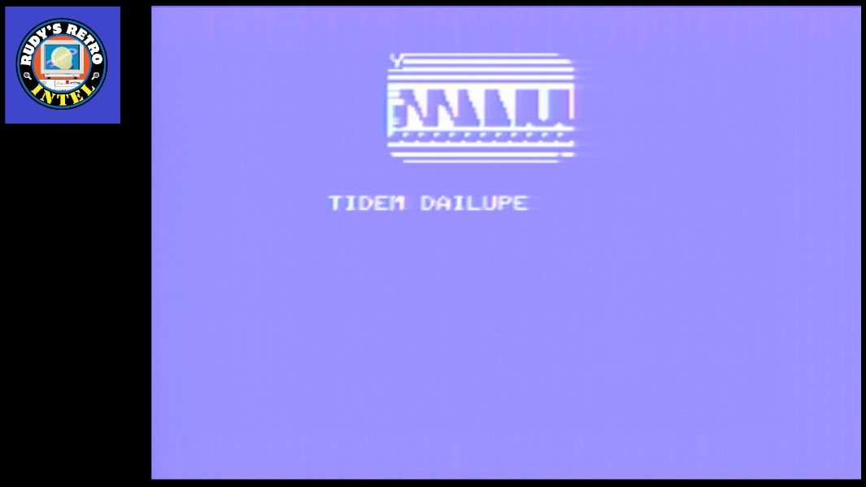

*Symptom*: NABU logo and text characters not shown correctly.

*Diagnoses*: Replace **U18** - TMS4116-15NL - DRAM 16,384-Bit (16Kx1) 150ns 5V.

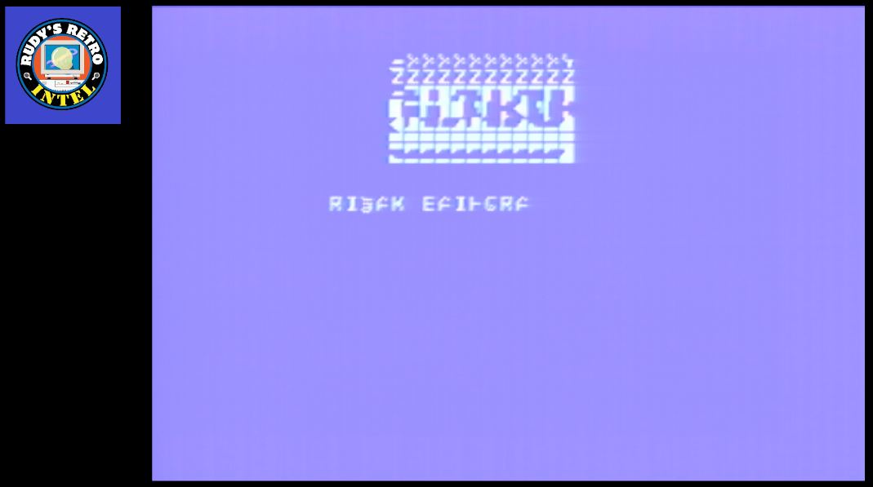

*Symptom*: NABU logo and text characters not shown correctly.

*Diagnoses*: Replace **U19** - TMS4116-15NL - DRAM 16,384-Bit (16Kx1) 150ns 5V.

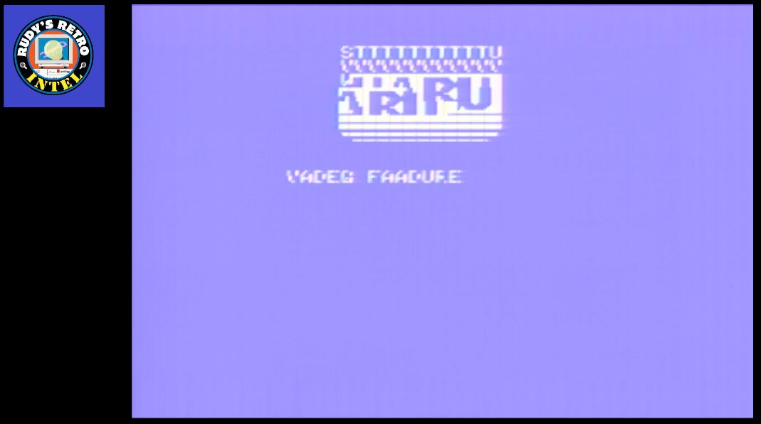

*Symptom*: NABU logo and text characters not shown correctly.

*Diagnoses*: Replace **U20** - TMS4116-15NL - DRAM 16,384-Bit (16Kx1) 150ns 5V.

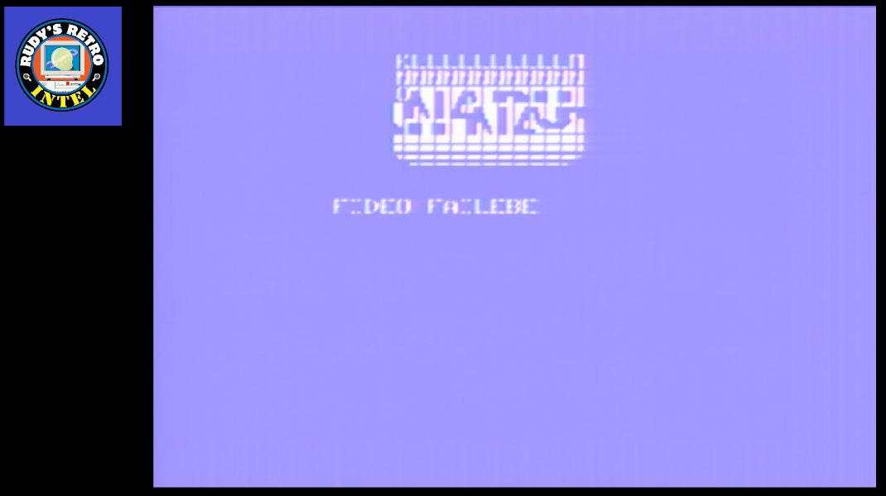

*Symptom*: NABU logo and text characters not shown correctly.

*Diagnoses*: Replace **U21** - TMS4116-15NL - DRAM 16,384-Bit (16Kx1) 150ns 5V.

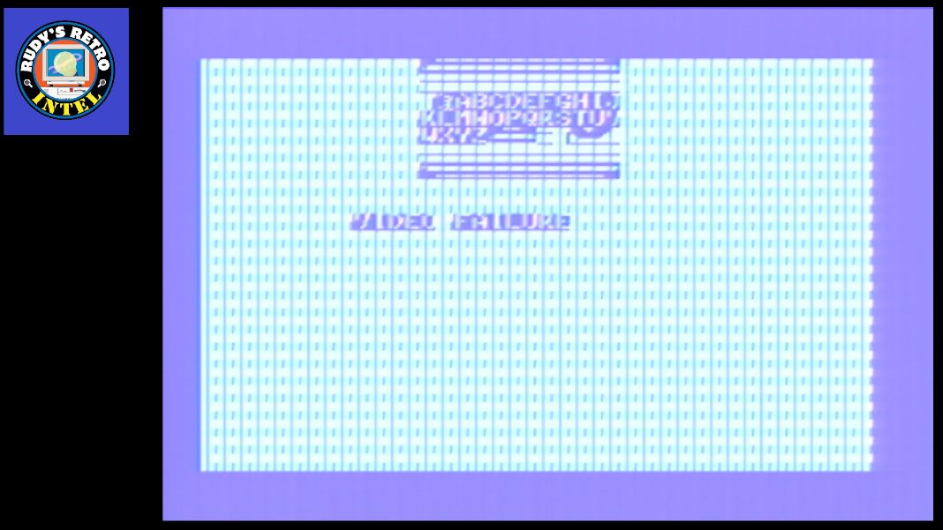

*Symptom*: NABU logo and text characters not shown correctly, inverse vertical bars displayed.

*Diagnoses*: Replace **U22** - TMS4116-15NL - DRAM 16,384-Bit (16Kx1) 150ns 5V.

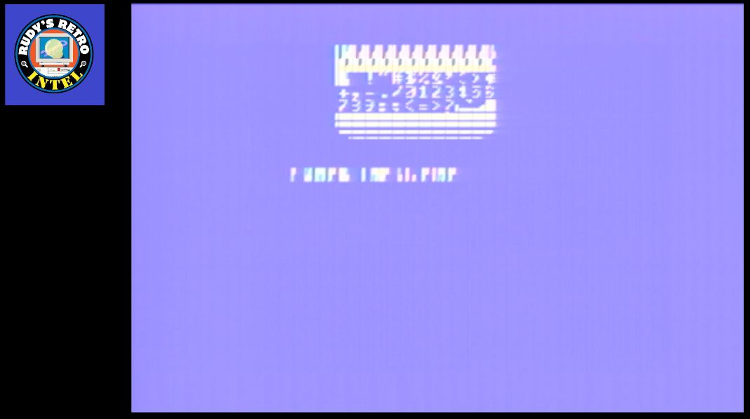

*Symptom*: NABU logo and text characters not shown correctly and\or blurred.

*Diagnoses*: Replace **U23** - TMS4116-15NL - DRAM 16,384-Bit (16Kx1) 150ns 5V.

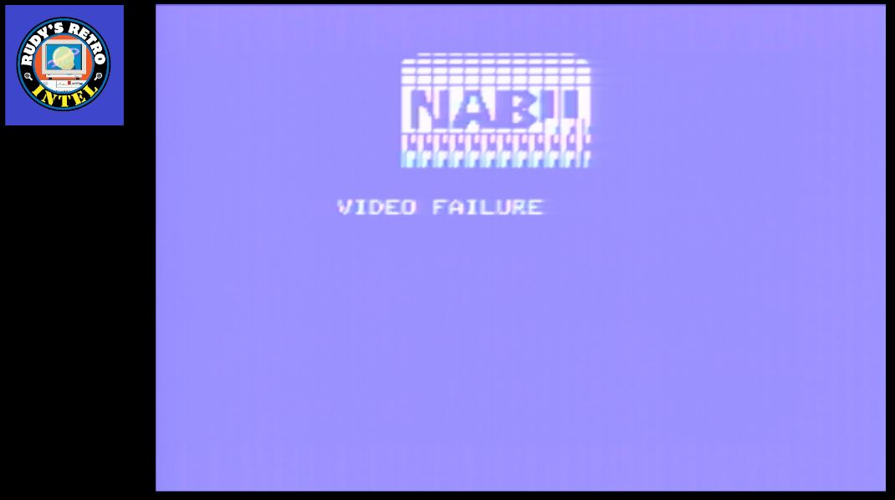

*Symptom*: NABU logo and text characters not shown correctly, displays video failure message correctly.

*Diagnoses*: Replace **U24** - TMS4116-15NL - DRAM 16,384-Bit (16Kx1) 150ns 5V.

**Card Slot Failure**

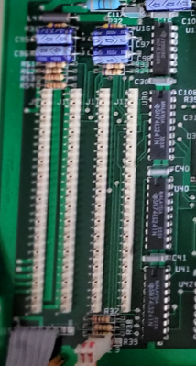

*Symptom*: Optional cards not working properly, not working, not recognized in slot J9-J12.

*Diagnoses*: Replace **U30, U40** and\or **U41** - 74LS241. **U9**, **U29** and\or **U37** - 74LS32. Check optional card and perform additional troubleshooting.

**Parallel Port Failure**

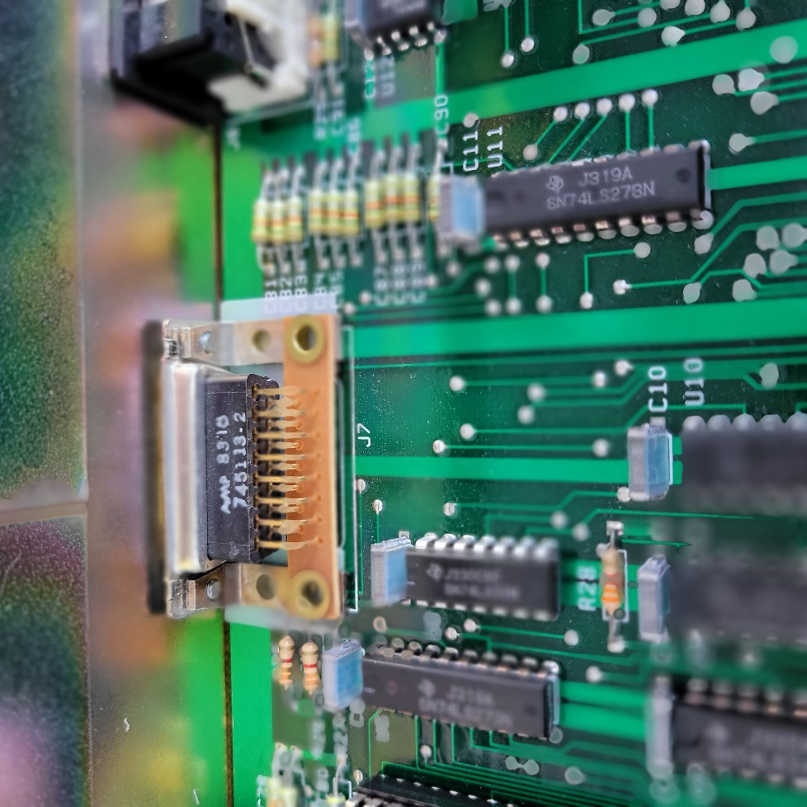

*Symptom*: Parallel port or device not working properly, not working, not recognized.

*Diagnoses*: Replace **U11, U6** - 74LS273, **U8, U27** – 74LS32, **U12** - UA9637ACP.

**NABU Computer Schematics**

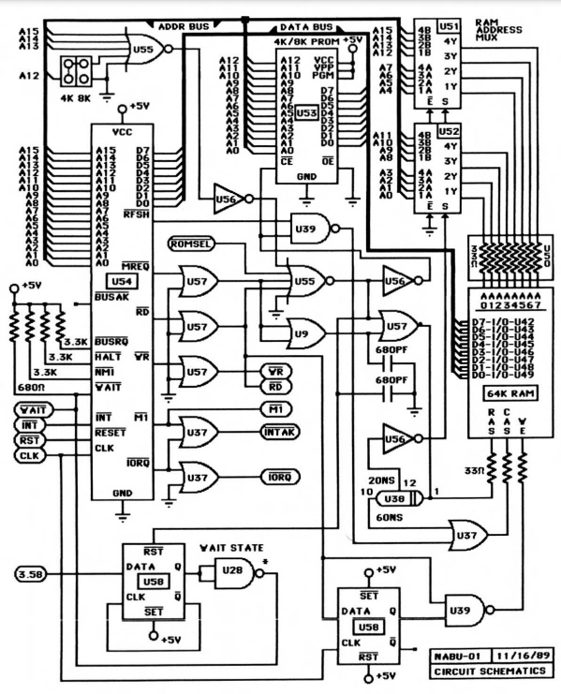

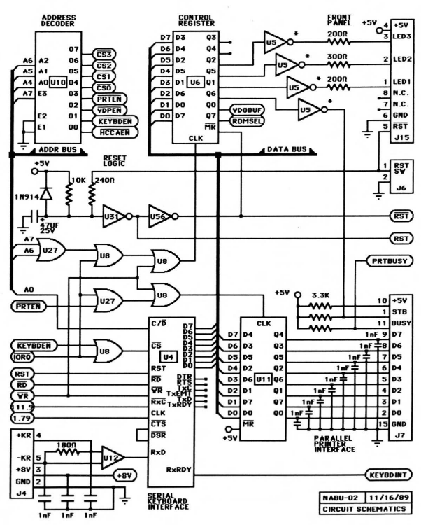

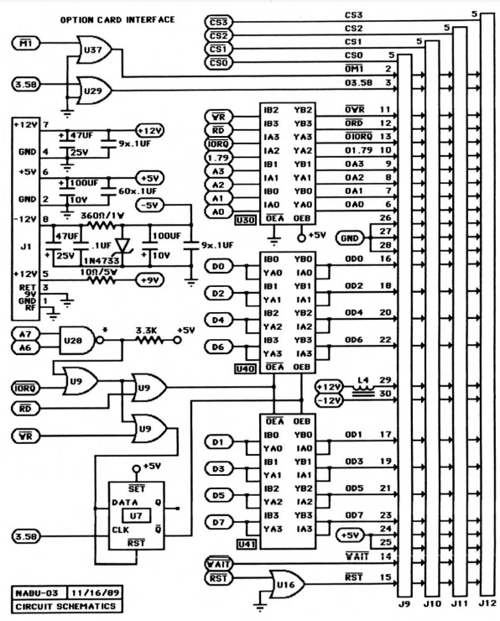

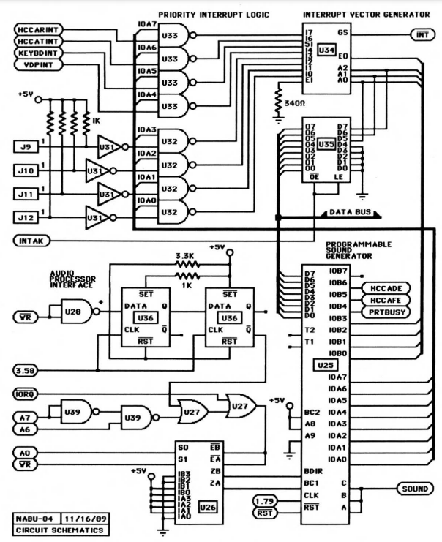

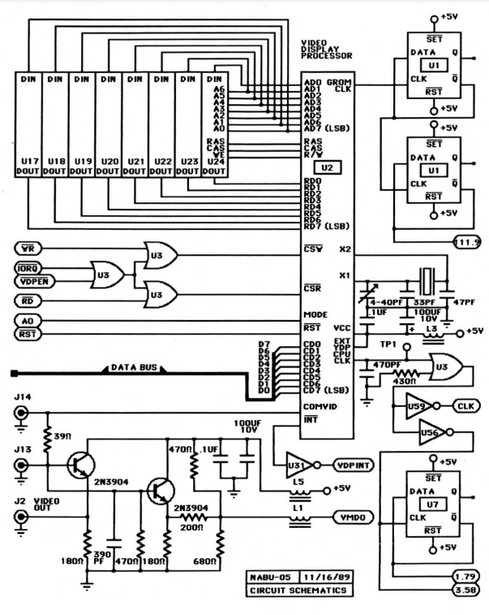

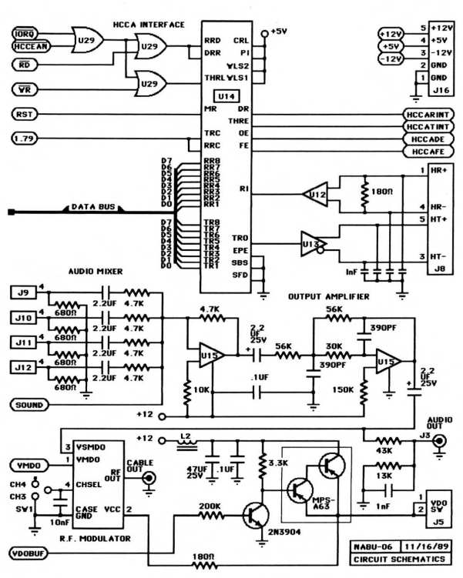

**IC location and Part Numbers**

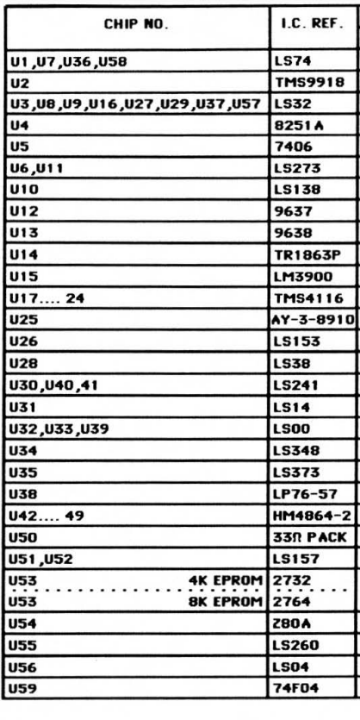

***\* Corrections: U14 is TR1863B-02 \****

**NABU Connector Pinouts**

Listed below are the pin outs and description for the connectors on the NABU computer.

**LED display connection is an 8-pin header**

Pin 1 = Power On indictor and is GREEN

Pin 2 = Pause indicator and is YELLOW

Pin 3 = Alert indicator and is RED

Pin 4 = Check indicator and is GREEN

Pin 5 = Reset Switch

Pin 6 = Ground\logical ground

**Adapter connection is a 5 pin DIN connector and uses the following configurations**

Pin 1 = Receive + (positive)

Pint 2 = Not used

Pint 3 = Transmit – (negative)

Pint 4 = Receive – (negative)

Pint 5 = Transmit + (positive)

**Power supply unit**

Power supply which is an ASTEC (AC8152) or a TDK (MRM146U) which outputs 40 WATTs

Voltage Output DC

Pin 1 = -12VDC (negative) with a maximum current of 0.5 Amps

Pin 2 = +12VDC (positive) with a maximum current of 2.5 Amps

Pin 3 = Common connection

Pin 4 = +5VDC (positive) with a maximum current of 5 Amps

**Game controller connection**

Pin 1 = Contact for UP movement

Pin 2 = Contact for DOWN movement

Pin 3 = Contact for LEFT movement

Pin 4 = Contact for RIGHT movement

Pin 5 = Not used

Pin 6 = Contact for FIRE control

Pin 7 = Not used

Pin 8 = Ground

Pin 9 = Not used

**Keyboard connection is a 6 pin DIN**

The keyboard uses a MC6801 micro processor

Pin 1 = Not used – use as shield ground

Pin 2 = +9VDC

Pin 3 = +9VDC

Pin 4 = Transmit +(positive)

Pin 5 = Transmit – (negative)

Pin 6 = Not used

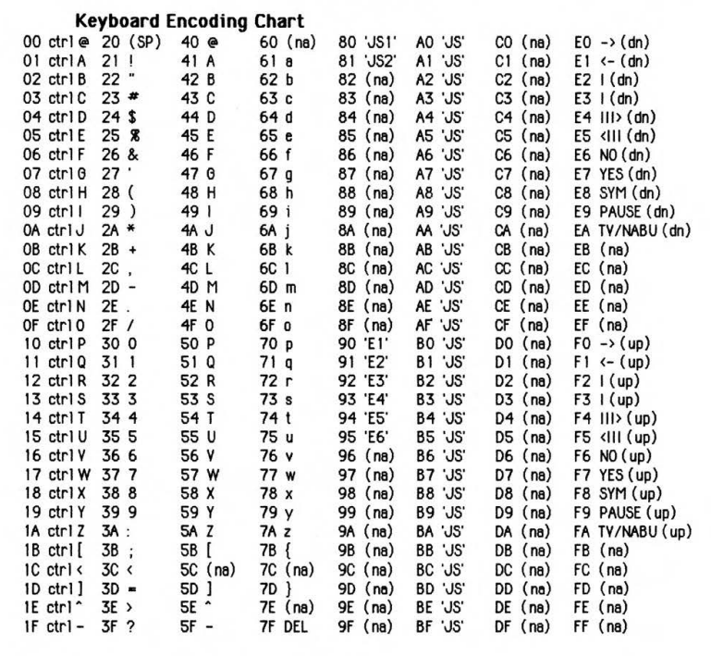

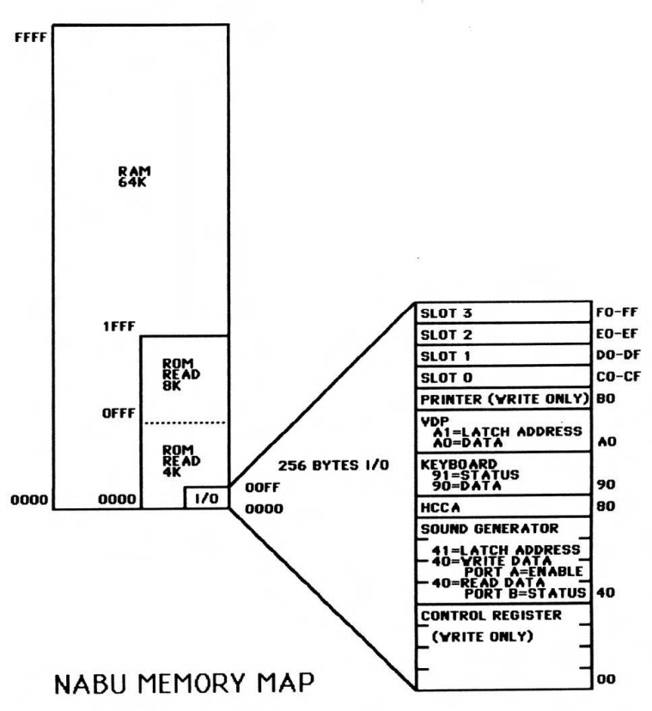

**Bodge Wires Connection**

On the back of the motherboard there are several bodge wire connections. Below are the images that show these connections. If some are missing or you need to remove them to perform repairs, these images could be used to help with the reattachments. Take pictures before removing wires.

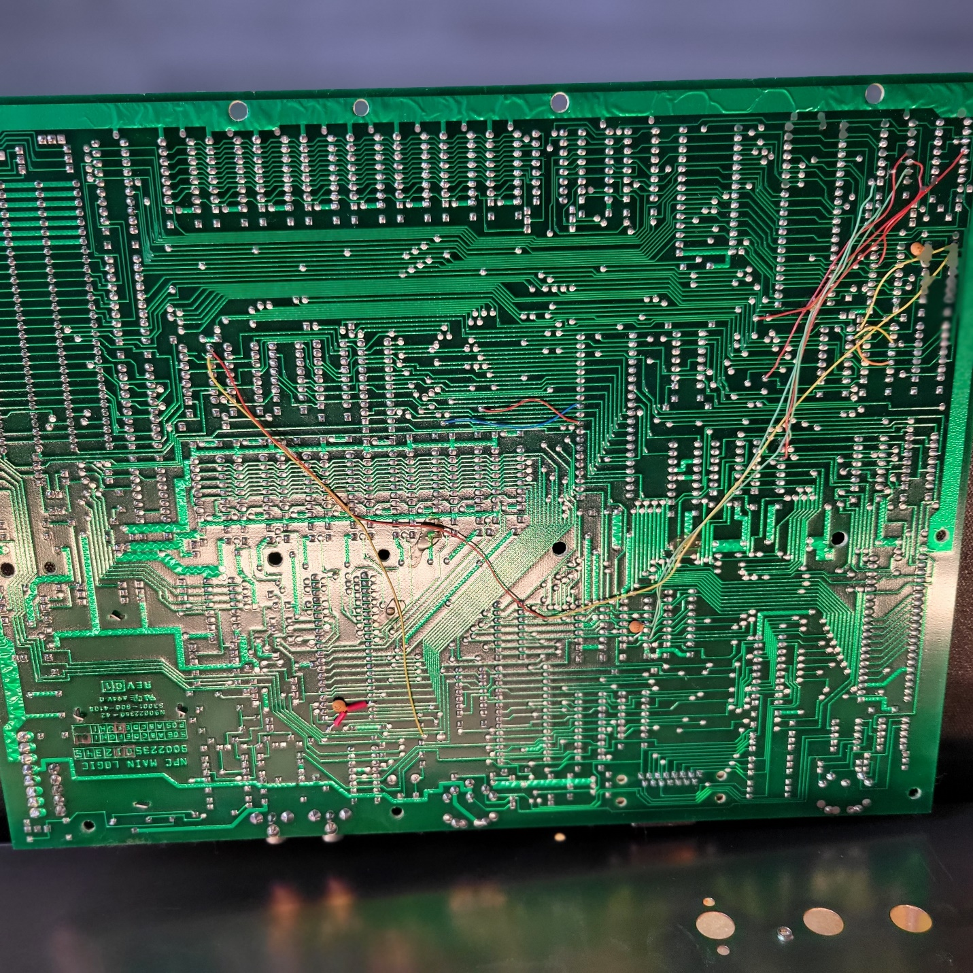

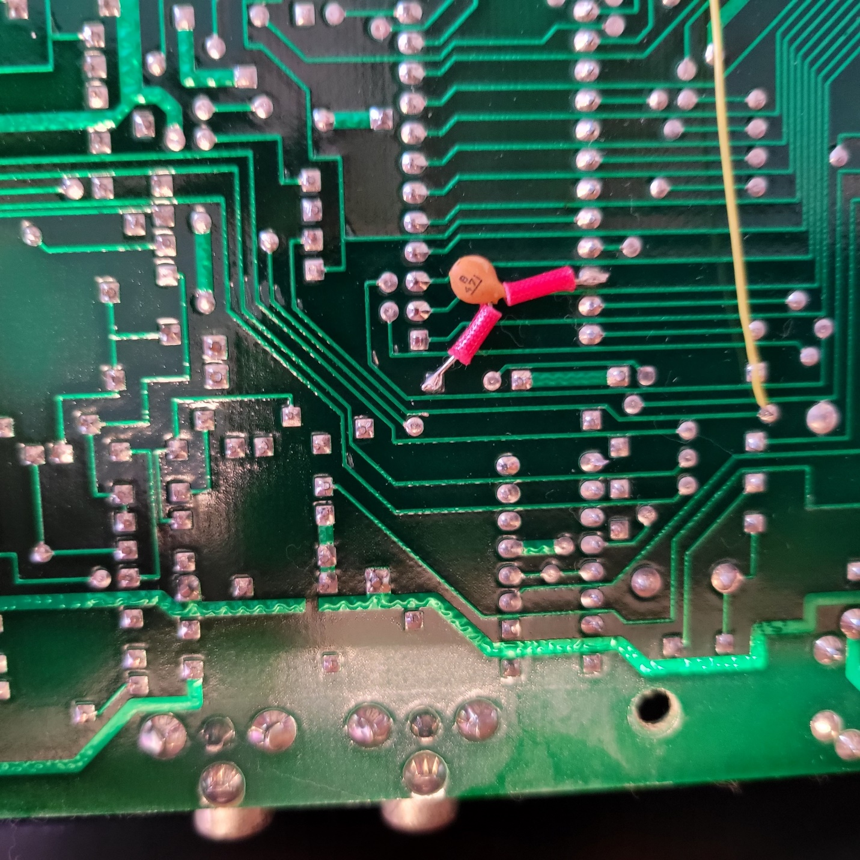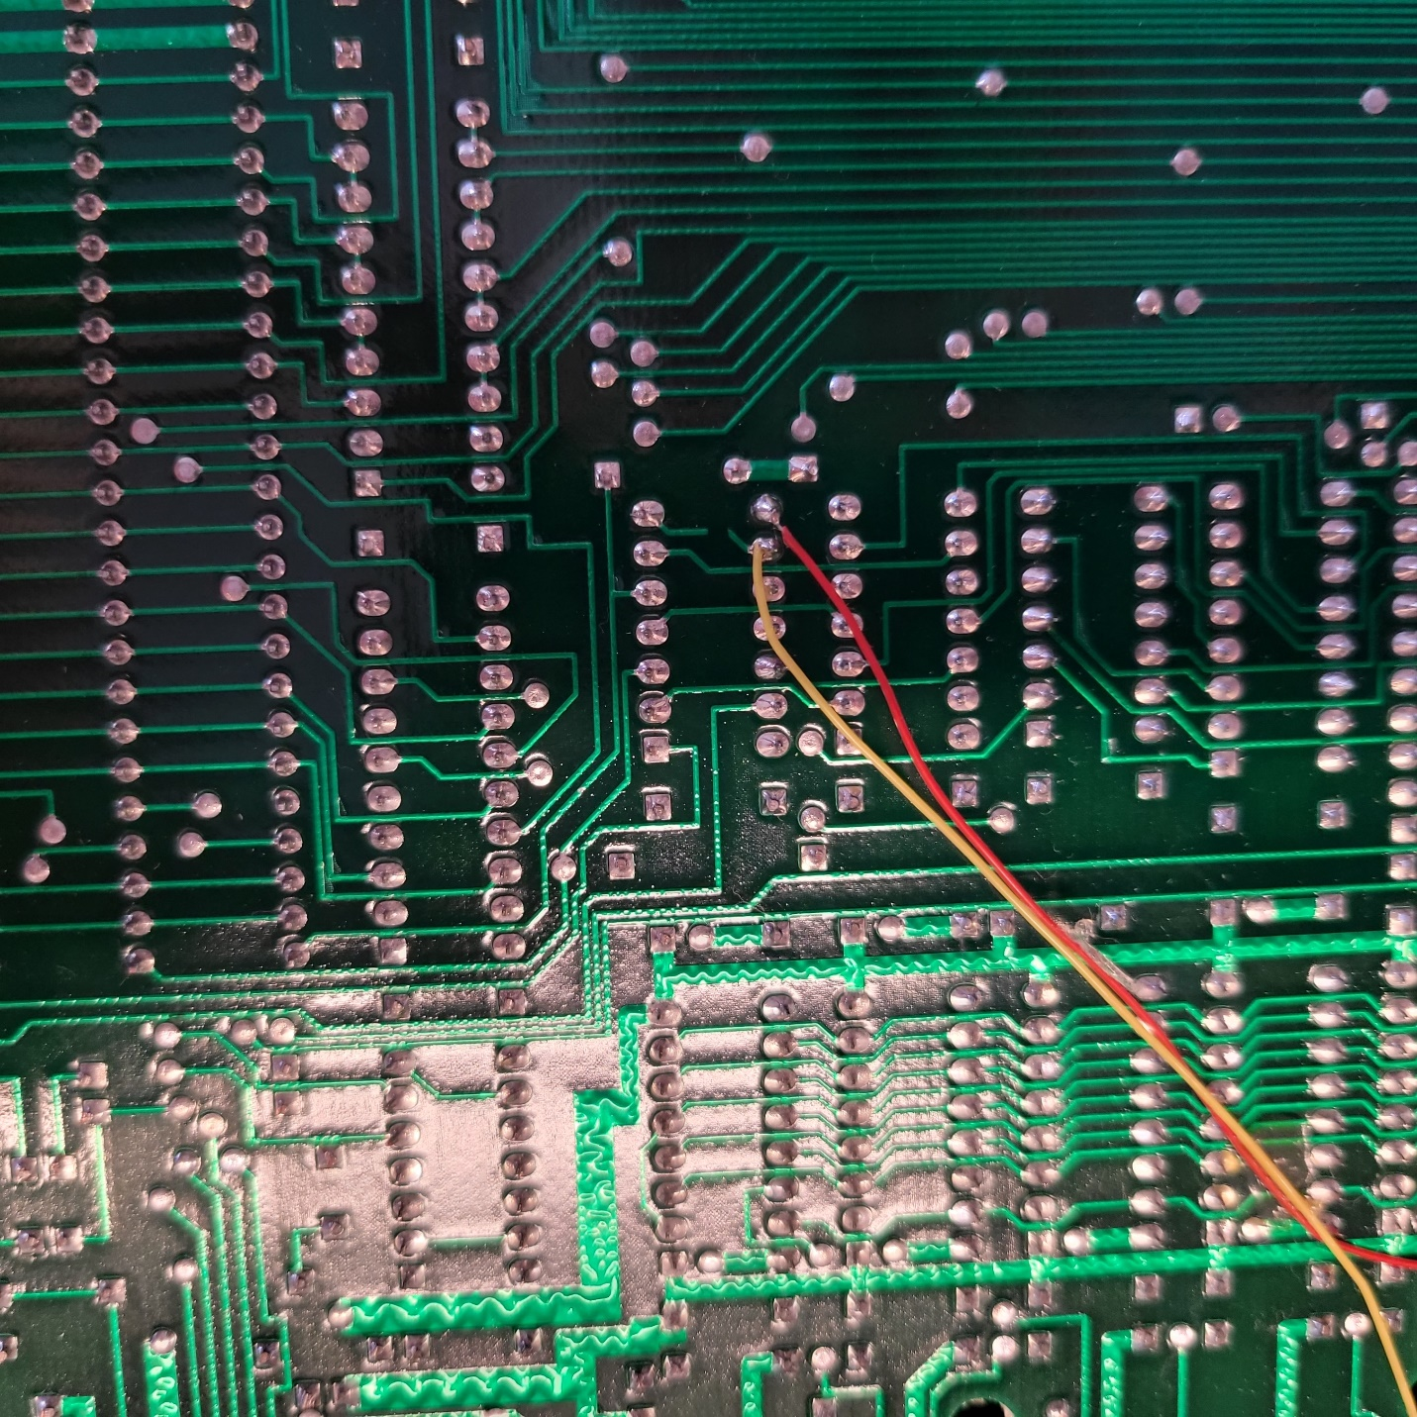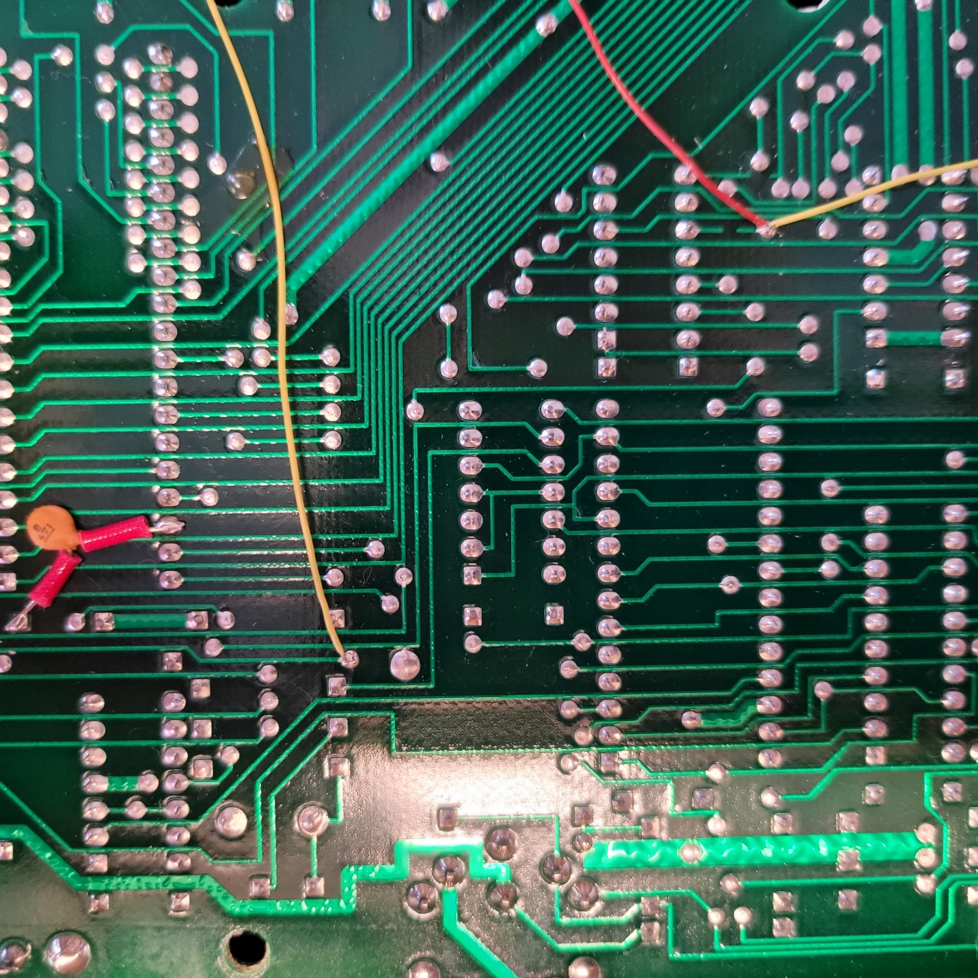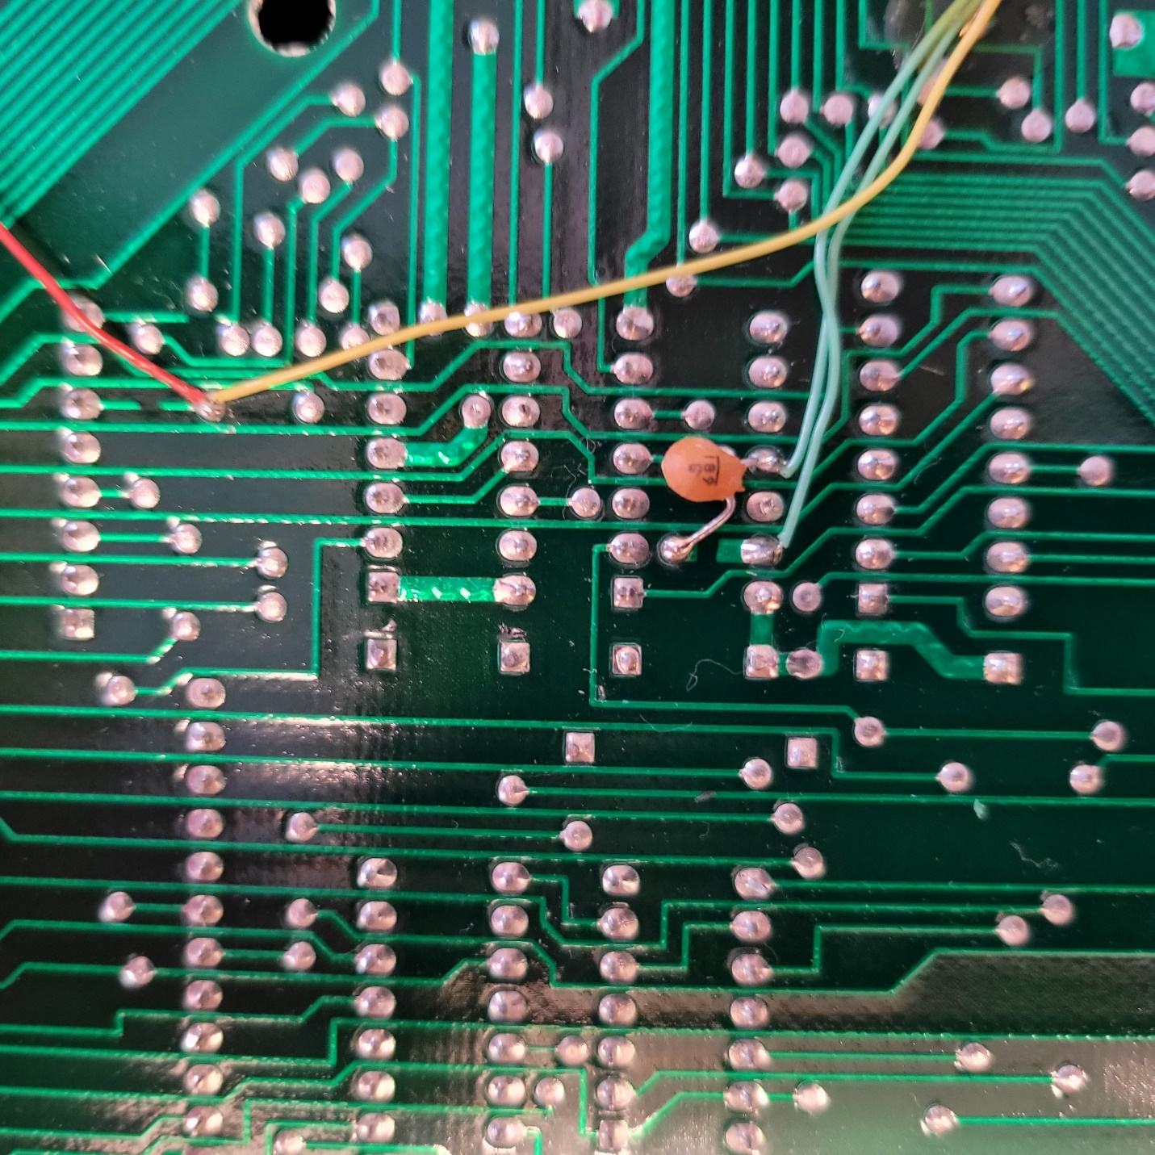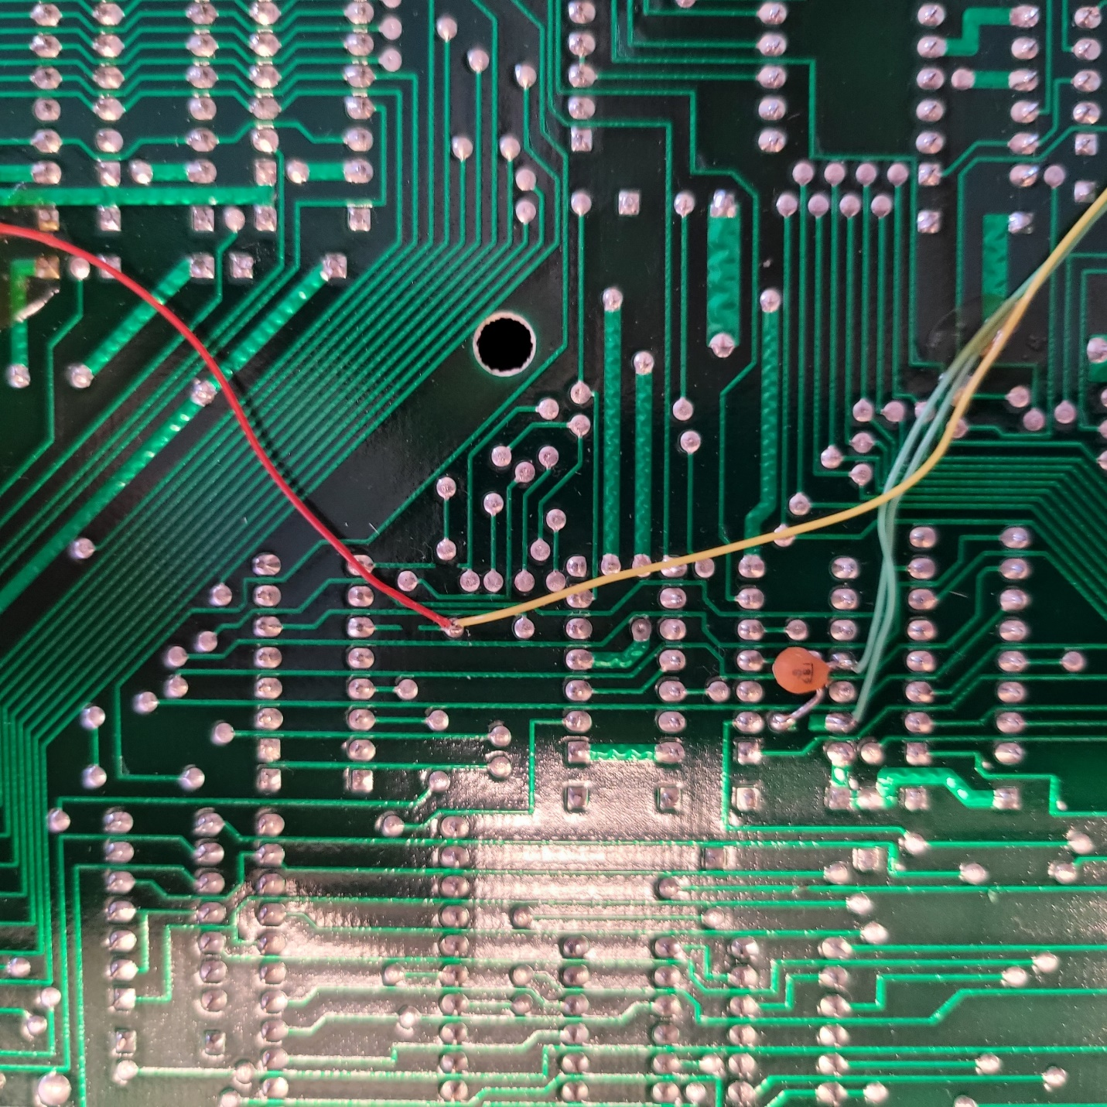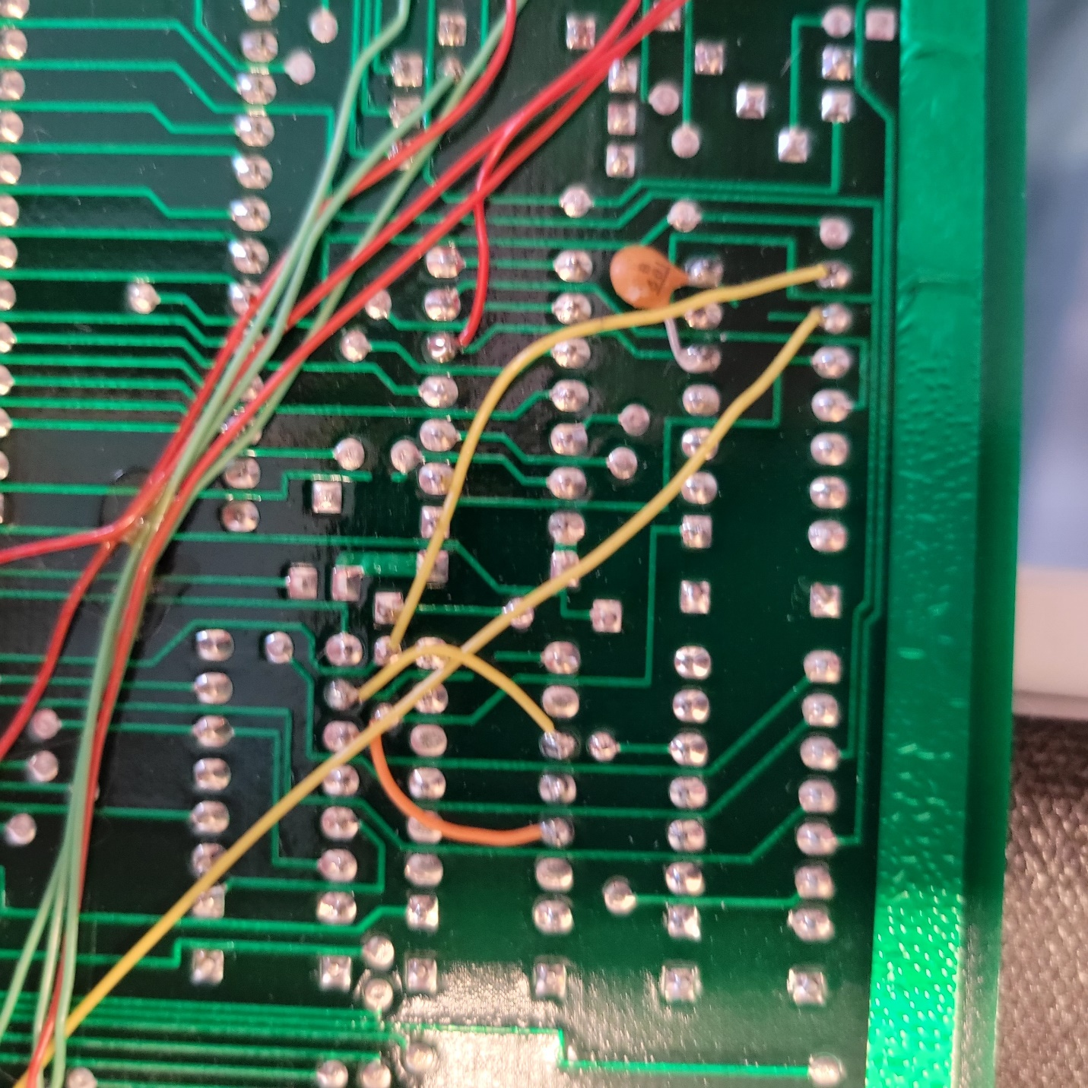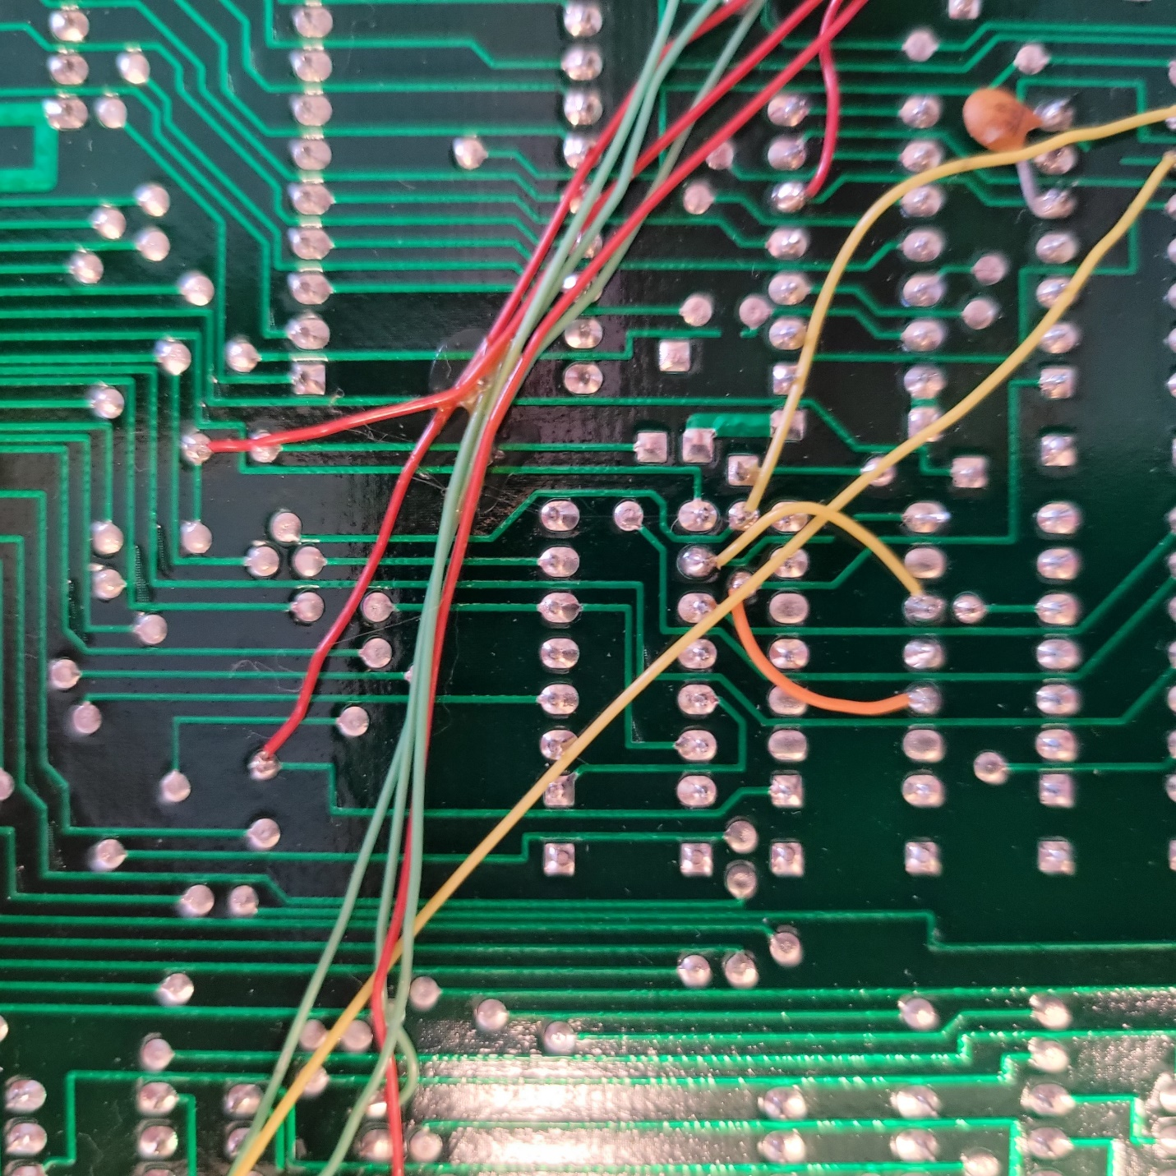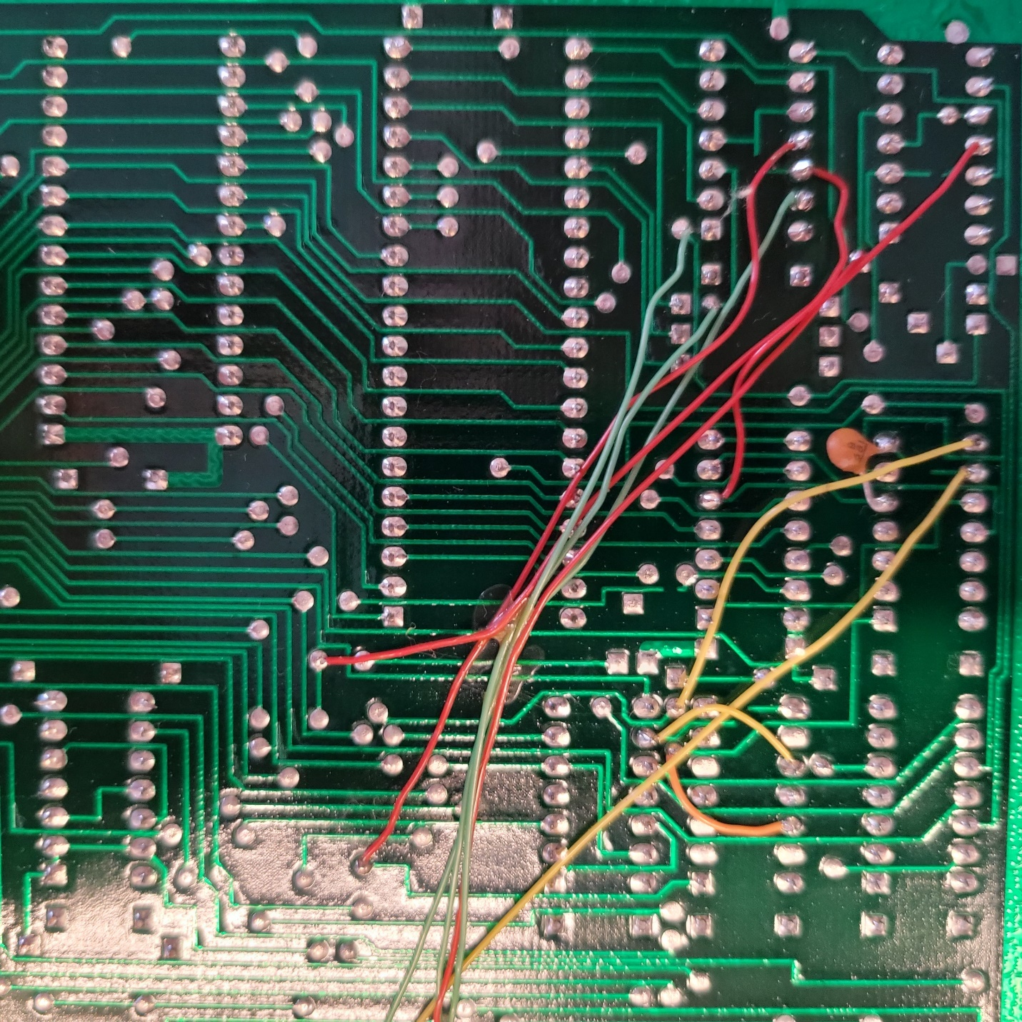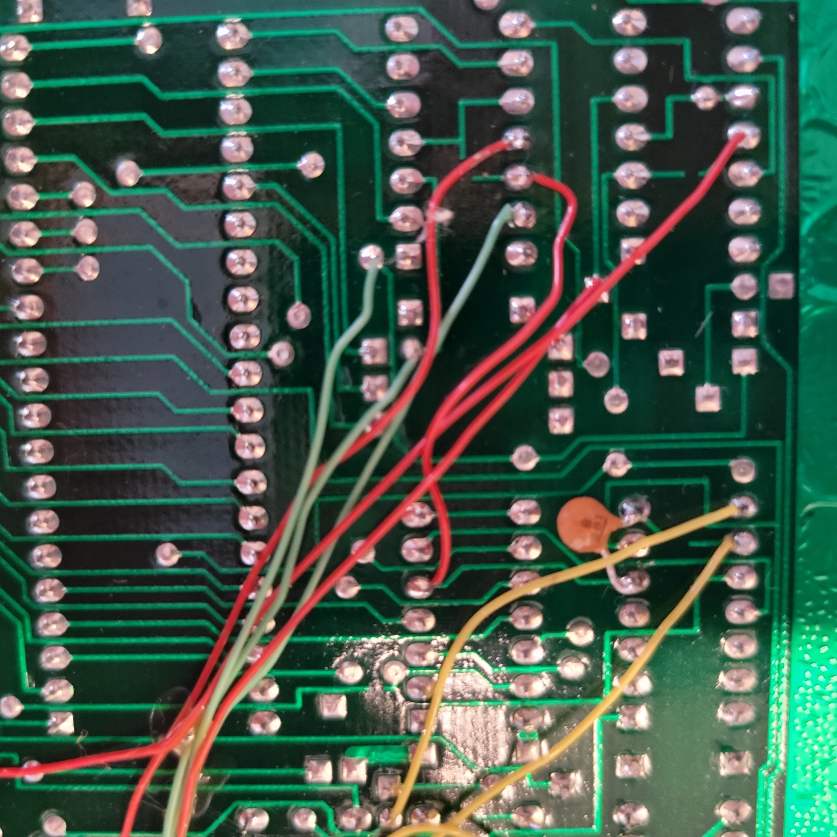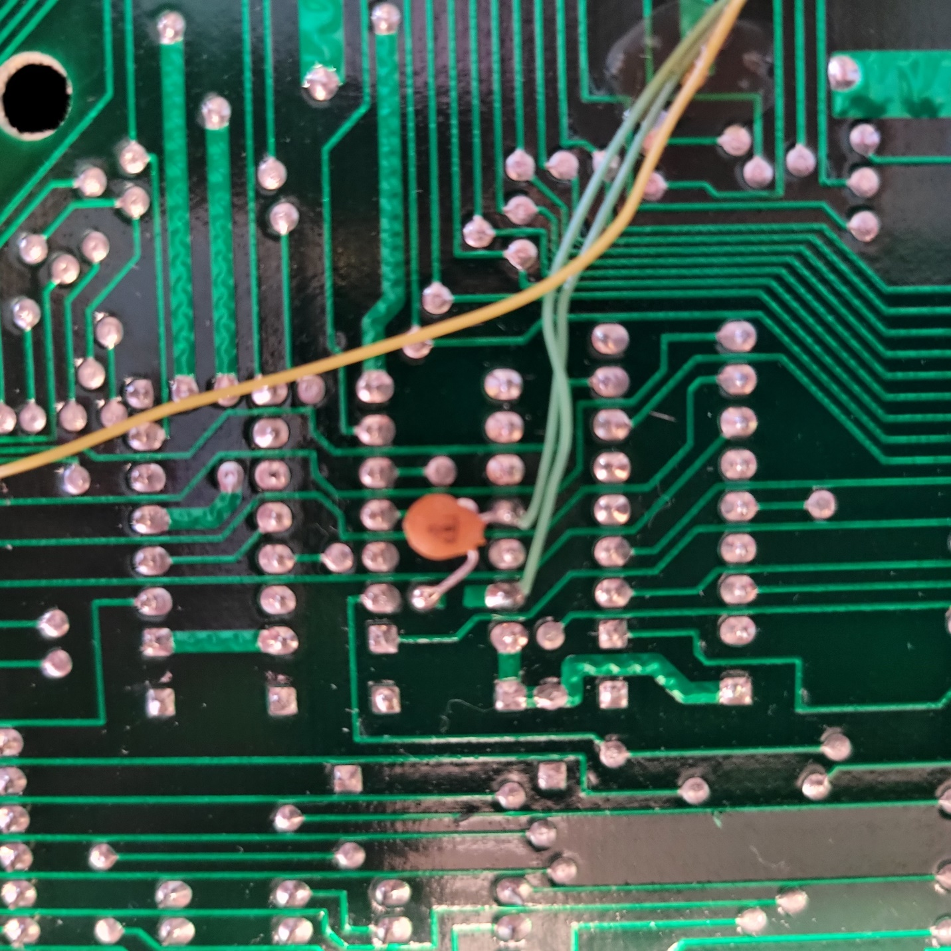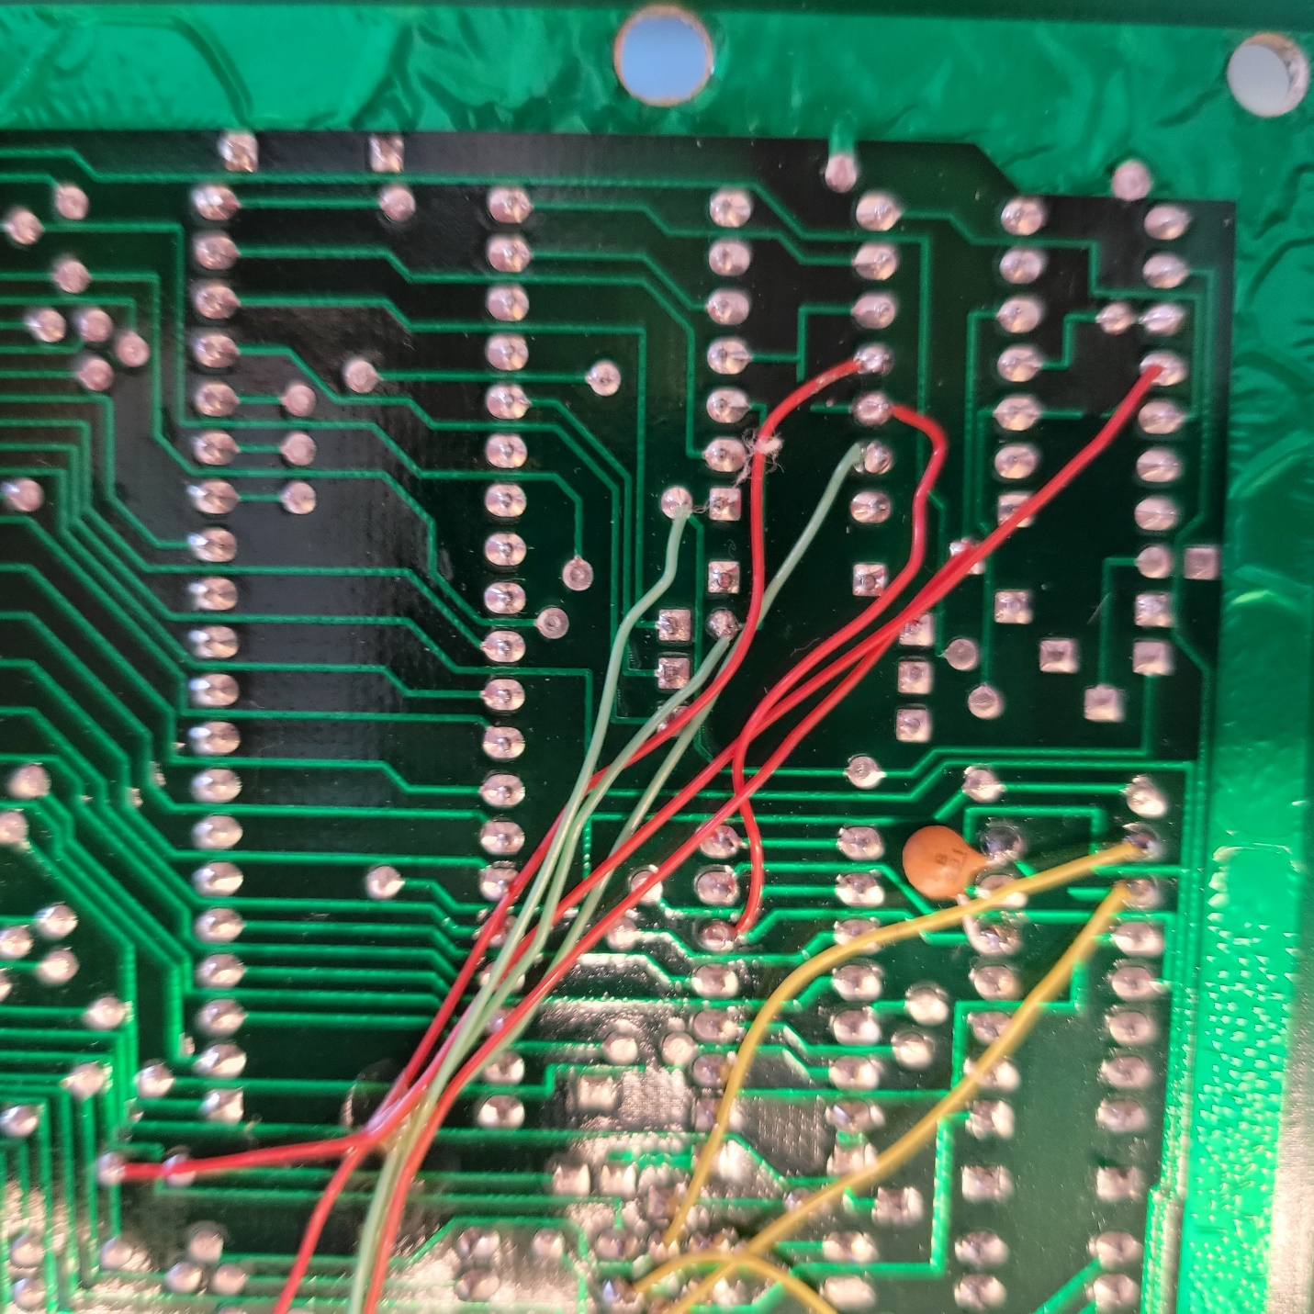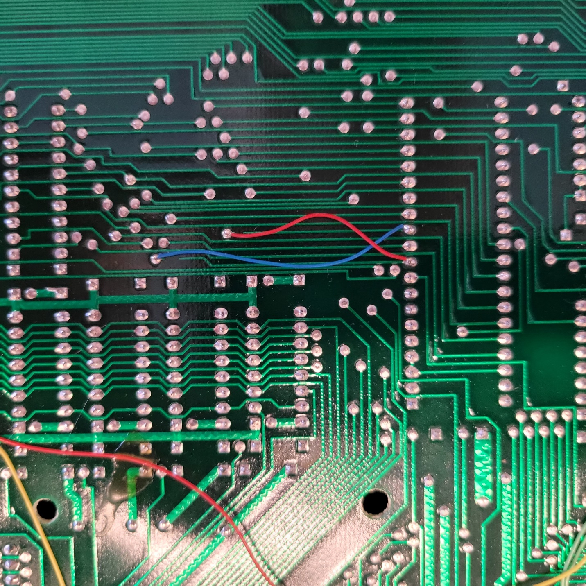

**IC Pinouts**

Video processor – TMS9919ANL pinout. TMS9919ANL is pin compatible with NAT9914BPD

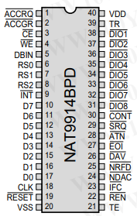

Z80 Processor pinout.

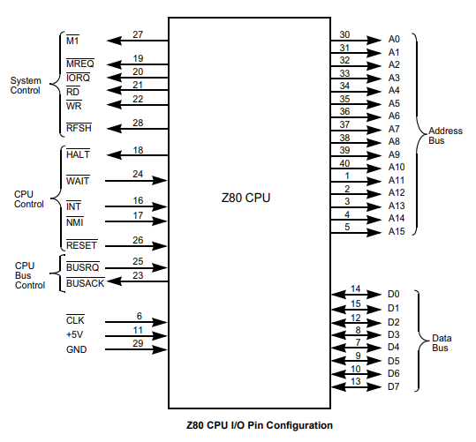

<https://www.jameco.com/z/Z80A-CPU-Major-Brands-IC-Z80A-4-8-16bit-CPU-N-Channel-Silicon-Gate_35596.html>

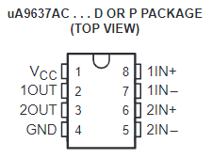

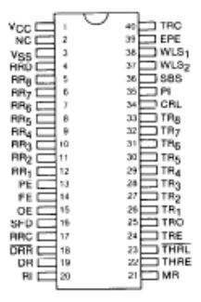

**TR1863B**

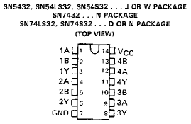

D8251AC – Programmable communication interface chip

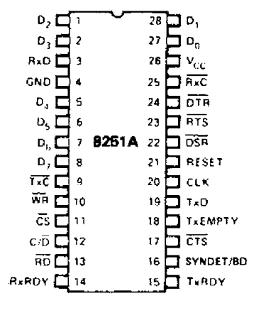

- <https://www.jameco.com/z/D8251AC-NEC-Corporation-IC-USART-8251-Dip-28_52644.html>

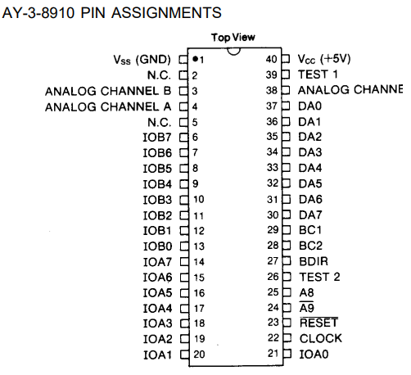

TR1863-B-02 – Universal Asynchronous Receiver/Transmitter



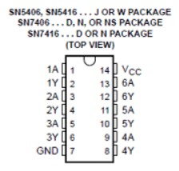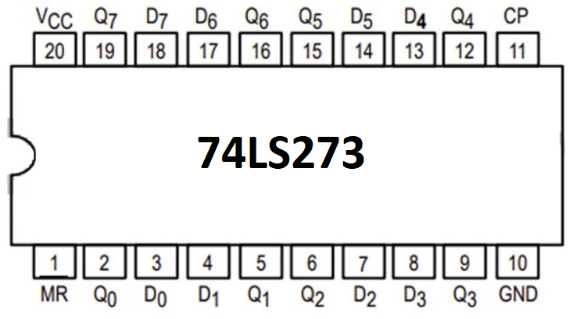

HM4864P – DRAM Chip DRAM 64Kbit 64Kx1 5VDC

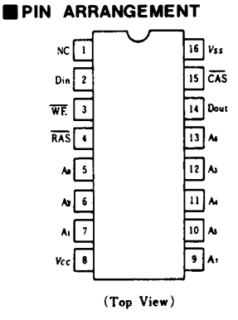 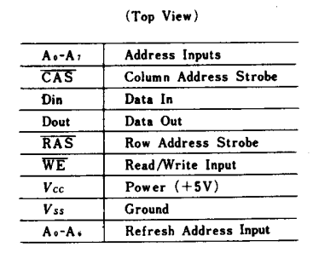

<https://www.datasheets.com/en/part-details/hm4864p-2-hitachi-62627550#datasheet>

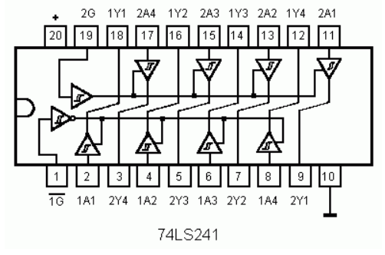

For addition IC pinouts, visit <https://www.futurlec.com/IntegratedCircuits.shtml>

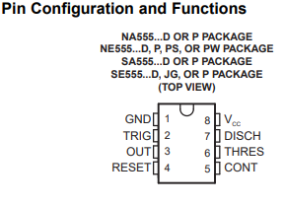 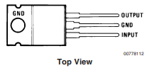

555 Timer 7805T

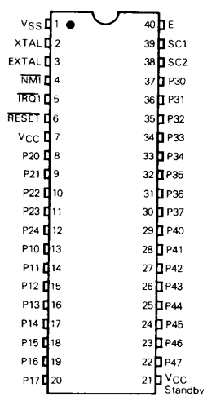

MC6801

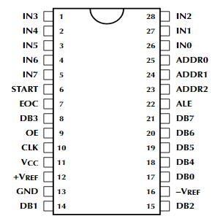

ADC0809CCN

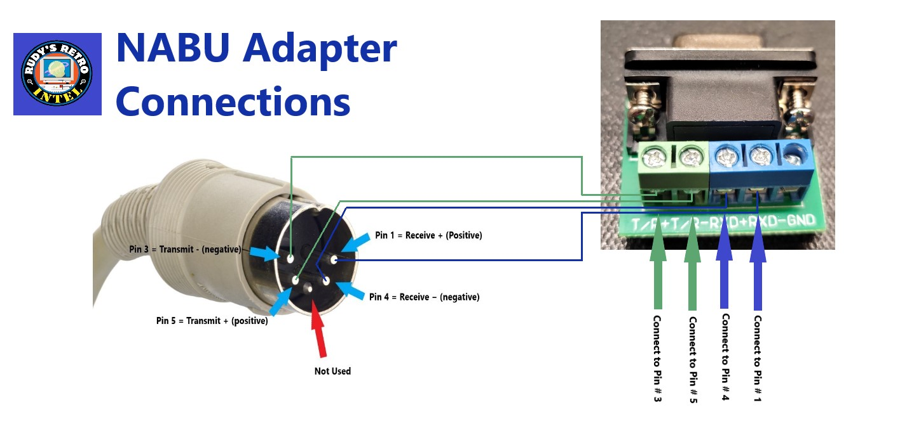For additional documentation on the adapter, please visit

<https://www.nabunetwork.com>

<https://github.com/RudyRetroIntel/Vintage-Computer-Diagnostics>